Exercise Manual

for

Quartus II Software Design Series: Optimization

Software Requirements to Complete All Exercises
Software Requirements: The Quartus II software version 8.0

Exercise 1:

Quartus II Incremental Compilation Exercise

Objectives:
- Practice Quartus II incremental compilation methodology on a team-based design flow
- Apply Quartus II incremental compilation when making changes to a design partition

Top-Level Design

In this exercise, you will practice the bottom-up design flow during team-based development. A project is being developed targeting a Stratix II EP2S15 device. As a designer on this team, you have been tasked with developing the following two subdesigns:

- Altera Finite Impulse Response (FIR) Filter MegaCore

- Data Encryption Standard (DES) Core

The project lead has already completed the initial floorplan for the device and assigned resources (e.g. pins) to your subdesigns. Of course, the resource allocation could be changed after some discussion with the project lead, if required.
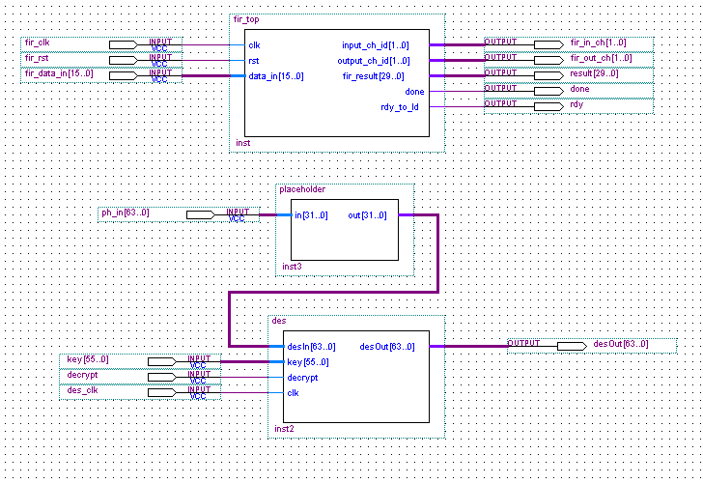
Step 1 (Review Top-Level for Incremental Compilation)
In this step, you will review the top-level project that has been set up by the project lead and the constraints associated with it, before starting on developing your subdesigns.
Launch Quartus 8.0 before starting the exercise (Start > all programs > Altera > Quartus II 8.0 > Quartus II 8.0 (32 bits)
- Open the project file. File => Open Project… and browse to directory <lab_install_directory>\ QIIO8_0\QIC\top_qic. Select project top_qic.qpf and click Open.
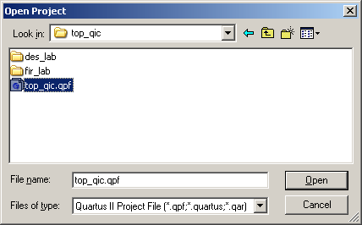

- Compile the design. Click on button, or from the Processing menu, click Start Compilation. Click OK when complete.
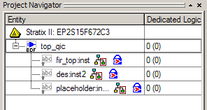
- Check the Project Navigator. Locate the Project Navigator (hierarchy tree) in Quartus II. Notice that hierarchy for this design.
You should see three subdesigns instantiated in top_qic. All three subdesigns have been set as design partitions and LogicLock regions. The top two subdesigns you will compile and import. The final subdesign, represented by placeholder:inst3, will be coming from another team member.
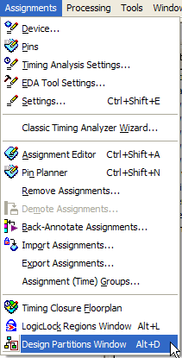
- Verify empty netlist type setting for partitions. From the Assignments menu, open the Design Partitions Window.
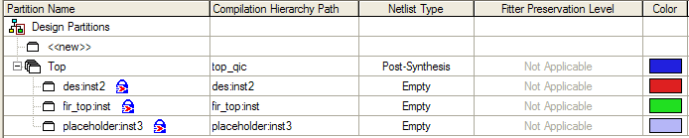
In the Design Partitions Window (shown above), you should see three partitions listed besides Top. Notice that the Netlist Type for these three partitions has been set to Empty. This is done so that the team lead can assign resources to each subdesign and prepare the top-level design to import netlists from the rest of the team.
- Open the wrapper file fir_top_bb.v for viewing. From the File menu, choose Open. Select the file fir_top_bb.v.
This wrapper file simply contains the name of the subdesign and the port listing. For Verilog designs, a wrapper file is needed to create a “black box”. Black boxes serve as placeholders in the hierarchy. Thus, the designer can create design partitions and make LogicLock assignments to the hierarchy, even though the logic for these subdesigns is not completed.
- Close the wrapper file fir_top_bb.v.
- View the floorplan for the top-level design. Click on button to open the Chip Planner. In the Task window (upper right corner of the Chip Planner), make sure the drop-down menu says Floorplan Editing (Assignment).
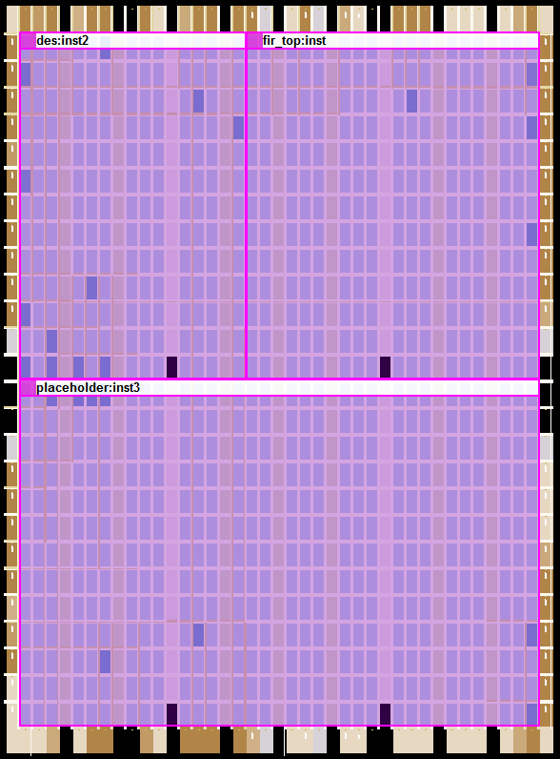
placeholder
fir_top
des
In the floorplan, you should see the placement of the 304 I/O pins and the virtual pins representing the partition boundaries (if you zoom in the virtual pins are cells colored in yellow). You should also see the FPGA divided into three areas defined by three LogicLock regions (the partition names do not appear in the floorplan like the image above).
Step 2 (Compile & Export des Project)
During this step, you will compile and optimize the des design block into the LogicLock region allocated in the top-level project. Afterwards, you will export a netlist for inclusion into that project. .
- Open the des project file. File => Open Project… and browse to directory <lab_install_directory>\QIIO8_0\QIC\top_qic\des_lab. Select project des.qpf and click Open.
- Analyze project and build hierarchy. From the Processing menu, click Start and then Start Analysis & Elaboration. Click OK when complete.
- Open the Design Partitions Window (Assignments menu).
In the Design Partition Window, you will see a design partition for des already created (since it is the top-level.).
- Change the Netlist Type to post-Synthesis
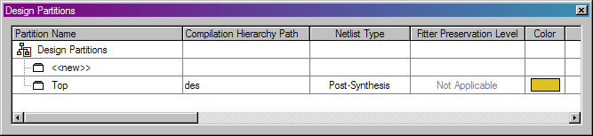

- Open the LogicLock Regions window. Click on the Assignments menu and select LogicLock Regions Window.
- Create LogicLock Region based on des design partition. In the Design Partitions window, right-click on Top (des) and select Create New LogicLock Region.
The LogicLock Regions window should now show an Auto, Floating region named des
- Set des LogicLock Region according to top-level design. In the LogicLock Regions window, double-click on the Size column for des (shown above) and select Fixed.
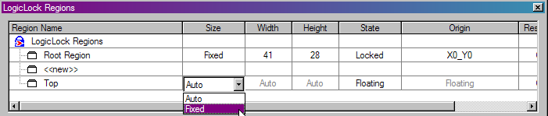
- Double-click in the State column for des and change Floated to Locked.
- Double-click in the Width column and type 17. Hit Tab key to move one column.
- In the Height column and type 13. Hit Tab key again to move one column.
- In the Origin column and type LAB_X1_Y14. Hit Tab or Enter key.
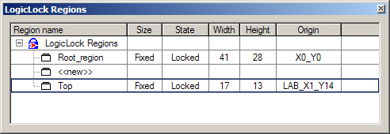
Your LogicLock Regions window should appear as shown above. Remember that this information could automatically be transferred from the top-level project if the bottom up script was used.
- Compile the subdesign. Click on . Click OK when complete.
- Check maximum frequency of des_clk signal. From the Timing Analyzer section of the Compilation Report, click on Summary. Record the maximum clock frequency from the table for des_clk. __________
Now you will perform optimization of the des block by constraining the clk signal. Of course, any available optimization settings could be performed on des to meet performance and area goals. Remember, that if the Netlist Type is set to Post-Fit, only source code changes will trigger a new place and route. For this reason, you will leave the Netlist Type set to Post-Synthesis. Thus, your optimization settings (that affect fitting) will be honored.
- From the Assignments menu, select Timing Analysis Settings.
- Enable TimeQuest. In the Timing analysis processing section, enable Use TimeQuest Timing Analyzer during compilation.
This tells the fitter to use TimeQuest and thus the file des.sdc during compilation. This file contains a clock constraint setting des_clk to 3.75 ns (267 MHz).
- Set the optimization effort to speed. Click Assignments > Settings, then click on the Analysis & Synthesis Settings category. Change the Optimization Technique from Balanced to Speed.
- Click OK to close the Settings dialog box.
Now you will assign the entire input data bus for des as virtual pins, since in the top-level design they are driven by registers in the placeholder.v subdesign.
- Open the Assignment Editor. From the Assignments menu, select Assignment Editor.
- Set the input bus desIn[63..0] to virtual pins. Double-click in the To column for row 2 (row 2 should be your clock assignment) and type desIn.
- Double-click in the Assignment Name column for desIn and select Virtual Pin from the drop down menu.
- Double-click in the Value column for desIn and select On from the drop-down menu.
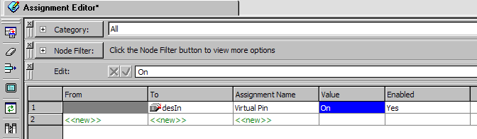
Your Assignment Editor window should look as above.
- Save and close the Assignment Editor file.
Now you need to apply the pin assignments allocated by the project lead. The project lead wrote them into a Tcl file, which has been placed in your project directory.
- Assign pins for subdesign. From the Tools menu, select Tcl Scripts… Select des_pin and click Run.
- Compile the design. Click on .
You will notice that this compile routine is longer than the first. The advantage of incrmental compilation is that you can perform optimizations and longer compile times on single design blocks instead of the entire FPGA desgin.
- From the TimeQuest Timing Analyzer section and record the maximum frequency (Fmax Summary) of des_clk. ________ MHz.
- Export the design. From the Project menu, select Export Design Partition. Leave all of the defaults and click OK.
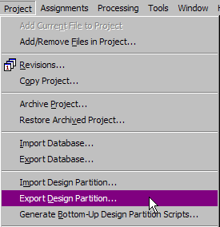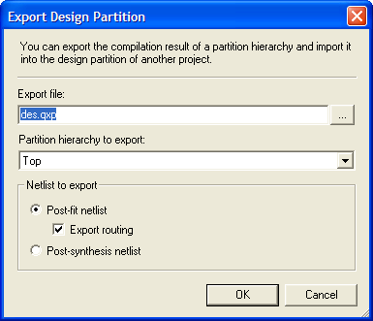
You have now generated a file called DES.QXP that is a netlist file you can import into the top-level.
For the fir_top subdesign, this block has already been optimized and the engineer working on it has generated a .QXP file. So that file needs to be imported into the top-level along with the des block.
Step 3 (Integrate Sub-designs into Top-Level Project )
You will now see the steps the project lead would perform to integrate the design.
- Open the top_qic project file. File => Open Project… and browse to directory <lab_install_directory>\ QIIO8_0\QIC\top_qic. Select project top_qic.qpf and click Open.
- Open Import Design Partition dialog box. From the Project menu, select Import Design Partitions.
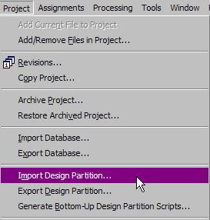
- Select partition name. In the Import Design Partition dialog box, click on the browse button . Select fir_top:inst and click on the right arrow to move it into the Selected partitions box. Click OK.
- Select the .QXP file to import. In the Import file box, click on the browse button for Location. Descend into the fir_lab subdirectory and select the file fir_top.qxp. Click Open.
- Back in the Import Design Partition dialog box, click Load Properties to see data on the region in which you are about to import.
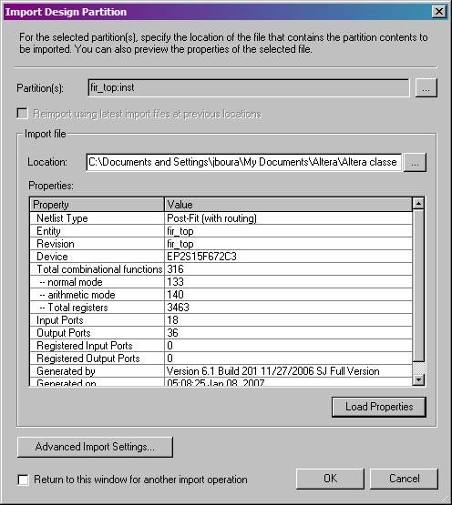
Your Import Design Partition dialog box should look as above.
- Click OK to close.
- Repeat #’s 2-6 for the des:inst2 partition located in the des_lab subdirectory.
- Open the Design Partitions window. (under Assignments menu)
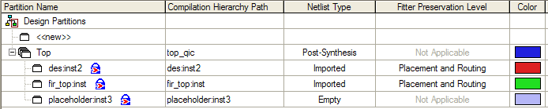
Notice the Netlist Type of fir_top:inst and des:inst2 have been automatically set to Imported.
- Enable TimeQuest in the top_qic project. Choose Timing Analysis Settings from the Assignments menu. Select Use TimeQuest Timing Analyzer during compilation.
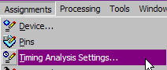
- Click on the TimeQuest Timing Analyzer category. Click on the browse button and add des.sdc to the project. Click Add. Click OK to close the Settings dialog box.
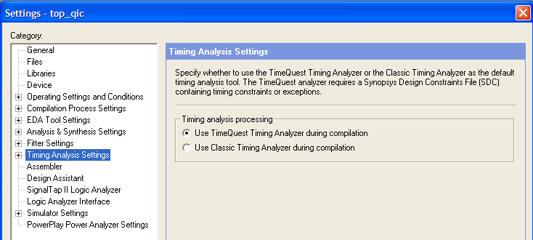
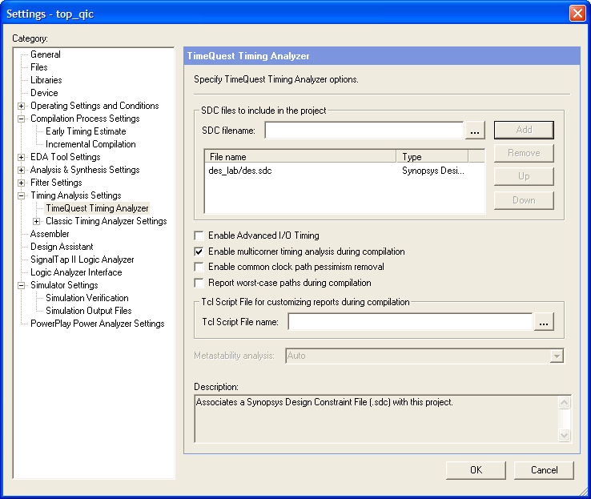
- Compile the design. Click on .
- From the Timing Analyzer section and record the maximum frequency of des_clk. ________ MHz.
- Open the Chip Planner and review the placement/layout of your imported regions.
Now you will lock these compilation results for future incremental compilations.
- Preserve placement and routing results for future compilations. In the Design Partitions window, set the Netlist Type for both the des partition and the fir_top partition to Post-Fit (Import-Based). Set the Fitter Preservation Level for both to Placement and Routing. You can do this by simply double-clicking in the columns.
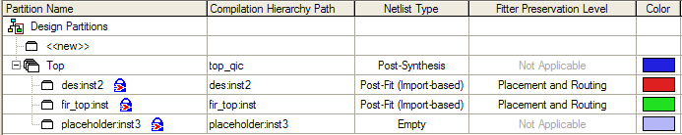
Your Design Partitions window should look like the above.
The lower-level designer now requests to make changes to the FIR filter design, specifically to increase the throughput of the filter. The appropriate changes have already been made for you, and re-exported into another .qxp file. As the top-level project lead, you must integrate the new design changes.

Step 4 (Make Changes to top_qic Design)
You will now integrate the new netlist (QXP file) into the top-level design.
- Re-import the new .QXP file for fir_top. From the Project menu, select Import Design Partition.
- Select partition name. In the Import Design Partition dialog box, click on the browse button . Select fir_top:inst and click on the right arrow to move it into the Selected partitions box. Click OK.
This time, notice that the Reimport using latest import files at previous locations option is enabled. With this option, Quartus II will automatically pick up the updated fir_top.qxp file. However in the case, the .QXP file name has changed.
- Select the new .QXP file. Uncheck Reimport using latest import… and click on the browse button for Location. Browse to the fir_lab directory and choose modified-fir_top.qxp.
- Click OK to close the Import Design Partition dialog box. Click OK once the import process is complete.
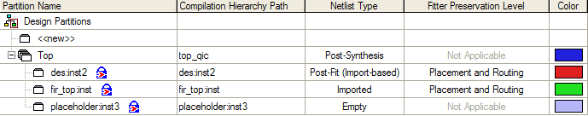
Notice that the netlist type for fir_top:inst has automatically changed back to Imported.
- Compile the design. Click on . Click OK when finished.
- From the Timing Analyzer section and record the maximum frequency of des_clk. ________ MHz.
Was there any change to des_clk? Review the floorplan of the design as well.

Exercise Summary

- Learned about the Quartus II Incremental Compilation flow
- Created design partitions and managed their compilation using LogicLock.
- Exported and imported netlist files to maintain compilation results between projects

End of Exercise 1

Exercise 2:

Timing Optimization

Objectives:
- Practice optimization techniques

Top-Level Design

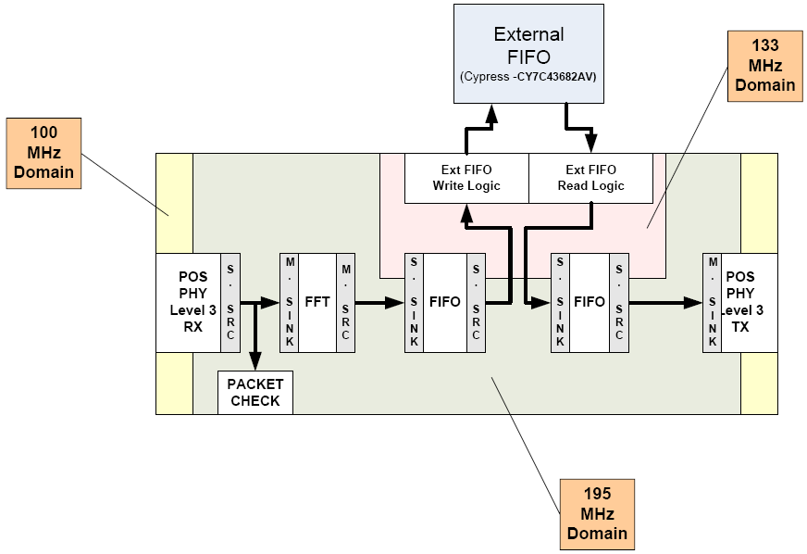

This networking design, named lab_design, implements a POS-PHY level 3 link between two systems. After being received by the POS-PHY Level 3 receiver block, the “packet check” block analyzes a packet of data to ensure it is correct, e.g. making sure that a packet is 1K words long and that the ERR flag from the receiver is not asserted. The packet then passes through an FFT and a series of FIFOs, with an external FIFO being used for increased storage capability. The packet is finally transmitted by the POS-PHY level 3 transmitter to another device.

There are 3 clock domains in the design, a 100-MHz external domain, a 195-MHz internal clock domain, and a 133-MHz domain to drive the external FIFO.

You will use this design to practice determining and resolving timing issues.

Step 1 (Open project and compile)
First, you will open and existing project and compile. The design has already been fully constrained.
- Open the project file. File => Open Project… and browse to directory <lab_install_directory>\QIIO8_0\OPT\. Select project lab_design.qpf and click Open.
The name of the top-level module in this design is lab_design. The name of the current Quartus II revision is lab_design_tq.
- Compile the design. Click on button or, from the Processing menu, click Start Compilation. Click OK when complete.
- Check timing summaries. In the Compilation Report, expand the TimeQuest Timing Analyzer folder. Click on the Setup Summary (appearing in red to indicate there are failing paths) to see that the SCLK domain is failing.
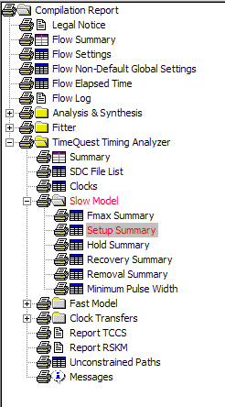
Step 2 (Run report to Analyze failing paths in TimeQuest to determine cause)
- Open TimeQuest. From the Quartus II Tools menu, select TimeQuest Timing Analyzer or click on the button in the Quartus II menu bar.
- In timequest, perform commands as shown
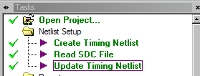

- Run a setup analysis report of the SCLK domain. From the Tasks pane in TimeQuest, choose Report Timing. Edit the following sections and choose Report Timing.
To clock SCLK
Analysis type Setup
Paths (Report number of paths) 200
Output (Detail level) Summary
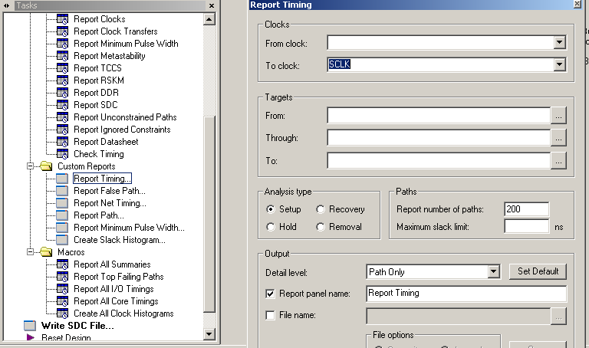
The Report Timing Summary report appears. What a sea of RED!!
Many times it is easy to get overwhelmed by a report such as this as it can be very difficult to figure out where you should start investigating. Some tips:
  - Look for patterns between From and To nodes. Grouping the nodes may help understand what’s failing, e.g. the interface between two modules or the nodes within a highly combinatorial module. It may also indicate that by fixing one or a few paths, you may be fixing related paths at the same time.
  - Look for From and To nodes that you recognize. If you recognize the module/node names, it may be logic you’ve written (as opposed to Megafunction modules) which means it might be easier to understand what the logic is and how you may fix the timing failures.
  - Fixing one or a few paths may inadvertently fix others. The compiler is trying to optimize many paths at once. If you are able to fix a path by editing the code or changing a constraint, it may free the compiler to work harder or other pieces of the design that were previously failing.
Step 3 (Fix parity checking logic failures)
The first path to fix will be the logic driving the error detection circuit of the parity checker. Click on the” from” column to sort the names. The first four entries are as shown
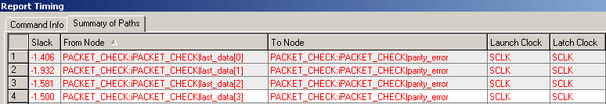

- View a detailed analyis of the failing paths. Right-click on the first line in the Report Timing Summary report. Select Report Worst-Cast Path.
A detailed report indicating this path is failing appears.
- Check the number of logic levels in the data arrival path. In the Data Arrival Path section of the detailed timing report, click on statistics to examine the number of layers
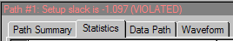

Is this a lot? It could be. Let’s check another way.
- View the path in the Technology Map Viewer. Right-click in the Data Arrival Path section and choose Locate Path. Select Technology Map Viewer and click OK.
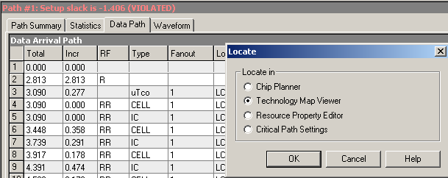

In the Technology Map Viewer graphical display, you can see that there are 12 logic levels between the last_data and parity_error registers. This is good evidence that this is a Case 1 timing failure: Too many logic levels.
Before fixing, let’s verify that the fitter did try to perform good placement.
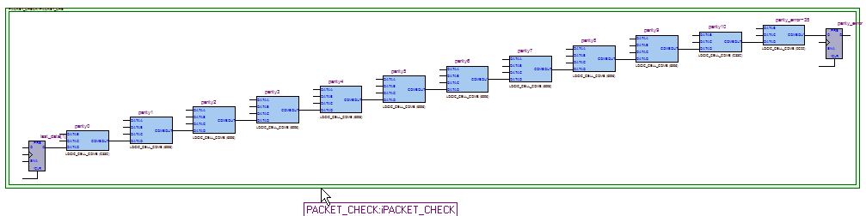

- Verify the placement in the Chip Planner. In TimeQuest, right-click on the Data Arrival Path again. Choose Locate Path. Choose the default setting of Chip Planner and click OK.
You will see that all of the nodes in this path are within two Logic Array Blocks (LABs) of each other, with only a few lines crossing between them. This is very good placement, so this is a good indication that the number of logic levels are the problem.
To fix this Case 1 timing path, you will add pipeline registers. This is a valid solution because, understanding the design, you know that when a parity error occurs, it is not critical that this error be caught immediately. A lag of a few cycles can easily be tolerated by the logic.
The code for the corrected design has already been written for you. This code involves adding multiple stages through the parity checking logic
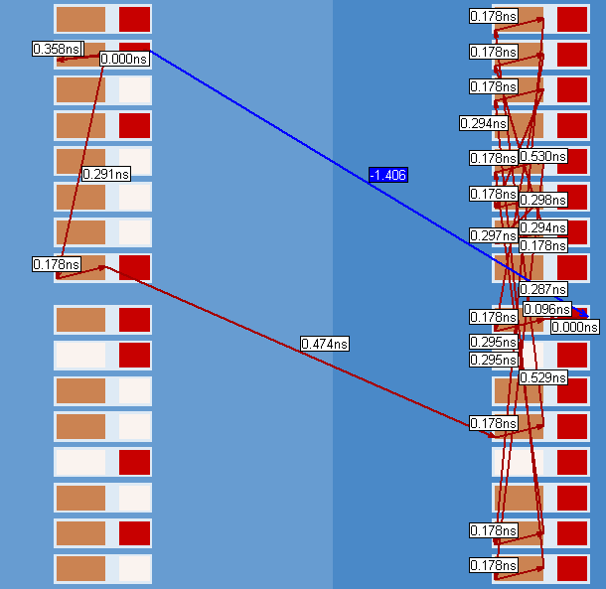
- Replace the packet_check.v file with an updated solution. In Quartus II, go to the Project menu and select Add/Remove Files in Project. Highlight and delete src/packet_check.v. Click on the browse button and choose src/packet_check_soln.v. Click Open and then Add. Click OK to close the Settings dialog box.
- Compile the design. Click on button
- Open TimeQuest.
- Run your setup report to verify the parity checking logic. From the Tasks pane in TimeQuest, choose Report Timing. Edit the following sections and choose Report Timing (type the To target in the field directly instead of using the Name Finder; case does matter. Just copy and paste from below).
To clock SCLK
To [get_pins iPACKET_CHECK|parity*|datain]
Analysis type Setup
Paths (Report number of paths) 20
Output (Detail level) Summary
From this report you can see that all parity checking registers are now meeting timing.
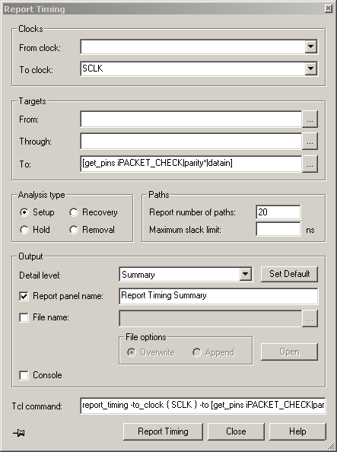

Step 3 (Fix remaining timing failures)
Now, you will analyze and fix the remaining timing failures in the SCLK domain.
- Re-run a setup analysis report of the SCLK domain. From the Tasks pane in TimeQuest, choose Report Timing. Edit the following sections and choose Report Timing.
To clock SCLK
Analysis type Setup
Paths (Report number of paths) 200
Output (Detail level) Summary
Again, this is done so that you can recognize patterns between the failing nodes. In the Report Timing Summary table. Click on the To Node column to sort out the names. Many of the first failing paths are all to the same To node, the sop_error (start of packet error flag) signal, coming from the FIFO address registers in the receiver block. This means that there is a chance they could all be fixed at once.
- Analyze the first failing sop_error path in more detail. Right-click on the first path in the Report Timing Summary and select Report Worst-Case Path.
- Check the number of logic levels in the data arrival path. In the Data Arrival Path section of the detailed timing report, click on statistics and examine the number of cell count
This time, there are few levels, so it appears the timing failures are probably not related to the number of logic levels. But, let’s verify this graphically.
- View the path in the Technology Map Viewer. Right-click in the Data Arrival Path section and choose Locate Path. Select Technology Map Viewer and click OK.
Unlike before, this path only shows a RAM block and 3 levels of logic, so it appears NOT to be a Case 1 timing failure. The path out of the RAM block is combinatorial. This means the total register-to-register delay includes the RAM block AND 3 logic cells. Does this make a difference?
- Review the detailed path report again. Go back to the detailed slack report in TimeQuest. In the Data Arrival Path section, go to line #4.
Notice in the Type column that this is cell delay. That means that the incremental value incurred by this line is the delay that passes through a cell of the device. The Location and Element columns indicate that the cell is actually an M4K memory block. How much delay does the M4K add? _________ (Look at the Incr column.)
Thus, even though there are only a few cells in the path, this is still a Case 1 timing failure. So how can you fix? Well, manually pipelining the block (e.g. by using the M4K output registers) might be impossible since this RAM is part of the POS-PHY MegaCore function. A multicycle assignment would fix the analysis, but should be used if the logic was designed to work in this way.
In this case, you can use register re-timing, under physical synthesis. Though this WILL increase compile time, it might also serve to fix the other timing errors being incurred by the design.
- Turn on physical synthesis. From the Assignments menu, choose Settings. Choose the Physical Synthesis Optimizations category under Fitter Settings. Enable Perform register retiming. Set the Physical synthesis effort to Fast. Click OK.
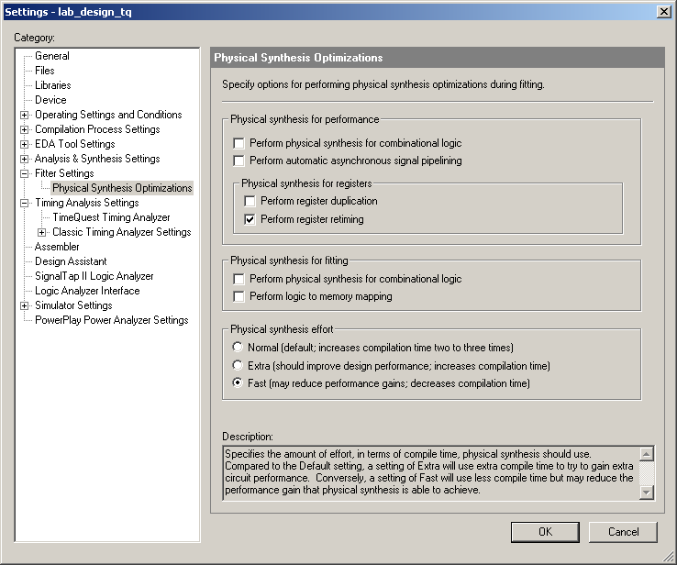

- Compile the design. Click on button or, from the Processing menu, click Start Compilation. Click OK when complete.
From the TimeQuest Timing Analyzer section of the Compilation Report, you can see that the Setup Summary is finally clean.

Exercise Summary

- Use Quartus II tools to analyze failing timing paths to determine their causes
- Use techniques discussed in presentation to eliminate failing paths

End of exercise 2

Exercise 3:

Timing Optimization using PLLs

Objectives:
- Practice optimization techniques
- Use PLLs to improve timing optimization results

Top-Level Design

In this exercise, you will take a design implementing a two-dimensional discrete cosine transform (DCT) and review why it is failing timing. You will then use optimization techniques including incorporating a PLL to improve design performance.
Step 1 (Open project and compile)
First, you will open an existing project and compile. This project has already been set up to use TimeQuest and an SDC file to control fitting. The device I/O have already been locked down so their moving around does not affect device timing.
- Open the project file. File => Open Project… and browse to directory <lab_install_directory>\ QIIO8_0\PLL_OPT\. Select project two_d_dct.qpf and click Open.
- Compile the design. Click on button
- Check timing summaries. In the Compilation Report, expand the TimeQuest Timing Analyzer folder. You should see only the Setup Summary appearing in red to indicate it is failing. What is your failing setup slack value? ___________
Step 2 (Analyze failing path in TimeQuest)
Use the reporting capabilities of TimeQuest to analyze why you are having setup slack failures.
- Open TimeQuest. From the Quartus II Tools menu, select TimeQuest Timing Analyzer or choose the toolbar button.
- In timequest, perform commands as shown
- Run the setup slack summary report. In the Tasks pane, double-click on Report Setup Summary.
As in the Quartus II Compilation Report, the Summary (Setup) report should show that clk is failing by -1.424 ns.
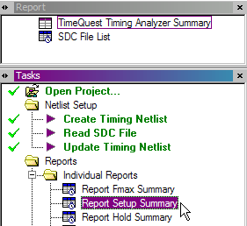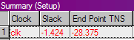
- Review more detailed information on the failing clock domain. In the Summary (Setup) report, right-click on row 1 and choose Report Timing. In the Report Timing dialog box, change the Report number of paths (Paths section) to 50 and use the Detail level: drop-down menu (Output section) to select Summary. Click on the Report Timing button.
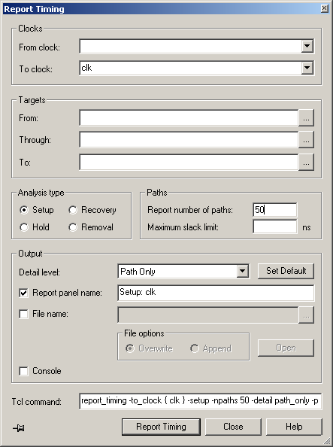

Why do this? This report is generated in order to determine how many paths are actually failing (e.g. a few paths versus hundreds of paths) and if any relationships can be found amongst the failing paths. Can you notice any such relationships?
  - You should notice that the top 23 failing paths are all between the design outputs (dct_out and data_valid) and the registers driving them, and that they are all failing by over 1 ns. You should analyze more closely to see if we are getting the best placement for the output registers.
- Analyze the detailed timing on a single output failing path. In the Setup: clk Summary table, right-click on the first failing path (data_valid). Choose Report Worst-Cast Path.
A detailed slack analysis report appears for Path #1. You will now try to discover which of the typical timing failures you are dealing with.
- Is this a Case 1 timing failure, too many logic levels? Look at the data arrival path for Path #1. How many target nodes does this path go through? So no, this is not a Case 1 timing failure.
- Is this a Case 2 timing failure, high fan-out signals? Look at the Fanout column in the data arrival path for Path #1. Are there any numbers that might signify fan-out issues? Since there are none, this is not a Case 2 timing failure.
- Is this a Case 3 timing failure, conflicting physical assignments? The only physical constraints that have been applied to this design are device I/O assignments, so that already is a hint that this might not be the issue. To further verify, look at row 3 of the data arrival path (Location column). You should see that the data_valid register (data_valid~reg0) has been placed in IOC_X0_Y20_N1 (an I/O cell block). This means that this register has already been placed as close to the device I/O as possible (for the best output setup timing). Thus, this is not a Case 3 timing failure.
- Is this a Case 4 timing failure, conflicting timing assignments? Since you didn’t create this design or build its SDC file, this one is a little more difficult. But, if you open the SDC file for the project, you will see that the design simply has the clock and I/O constrained. Plus, if there was an internal constraint interfering with this I/O register placement (like a clock setting), it would more than likely be trying to pull the register OUT of the I/O cell.
- Finally, is this a Case 5 timing failure, tight timing requirements? Since you have ruled out all the other failures and you verified that the output register has already been placed in the best possible location for output setup timing, Case 5 is probably the problem.
So what are the solutions? According to the possible solutions from the presentation material, you could add multicycle assignments or go back and re-evaluate your timing constraints to verify if maybe you are over-constraining the I/O (i.e. your output maximum delay is too large). The solution you are going to employ in this exercise is to use a PLL to shift the output clocks.

Step 3 (Add PLL and synchronization register and analyzer timing)
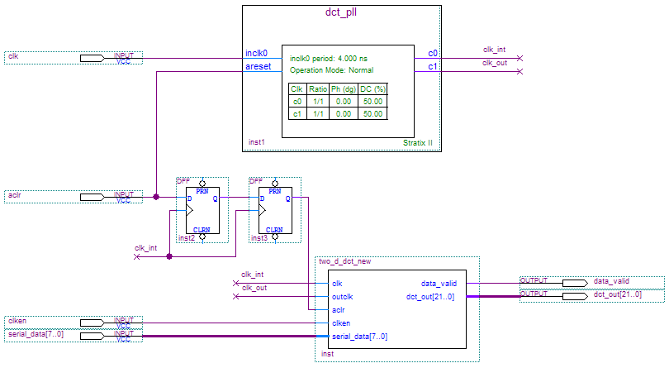
A new top-level design file (top_dct.bdf) has been created for you. It incorporates a PLL named dct_pll as well as adds some synchronizations registers to your asynchronous input path.
- Create a new revision for the design changes. From the Project menu of Quartus II, choose Revisions. In the Revisions dialog box, click on the Create button. Name the new revision top_dct, based it on the two_d_dct revision. Click OK to close the Create Revision dialog box and OK again to close the Revisions dialog box.
- Open the file top_dct.bdf. From the Project menu, choose Set as Top-Level Entity (near the bottom).
Notice the top-level entity name shown in the Project Navigator is now top_dct. Take a second and look over the design file. Notice that two_d_dct (now called two_d_dct_new) is now a module in the design and that a new input has been added to it called outclk. This outclk signal fed by the PLL allows you to adjust the phase of the clock driving the output registers independently of the internal clock.
All of the top-level I/O names remained the same.
A new SDC file, named top_dct.sdc, has also been created for you that incorporates the PLL settings.
- Specify top_dct.sdc as the SDC file for this revision. Go the Assignments menu and choose Timing Analysis Settings. Select the TimeQuest Timing Analyzer category. Remove two_d_dct.sdc as the SDC and replace with top_dct.sdc. Click OK to close the Settings dialog box.
- Compile the design. Click on button, or from the Processing menu, click Start Compilation. Click OK when complete.
- Check timing summaries. In the Compilation Report, expand the TimeQuest Timing Analyzer folder. The Setup Summary is no longer in red indicating that the problems have been fixed with the introduction of the PLL
What happened to the failing paths on all of the output pins (now driven by clk_out? One of the functions of the PLL is to effectively remove clock tree delay, thus your clock-to-output times decreased and now you can meet your output delay requirements..
- Verify the above information regarding the output registers. Open TimeQuest. In the Tasks pane, double click on Report Timing. In the To: field (Targets section), type data_valid. In the Detail level: field (Output section), use the drop-down menu to select Full Path. Click Report Timing.
This time, you will see full path for the clock expanded. On line 6 of the Data Arrival Path, you can see that the PLL inserts a -5.049 ns phase compensation offset to account for the global clock tree delay. This reduces the data arrival time enough for you to meet your setup time requirement for the outputs.
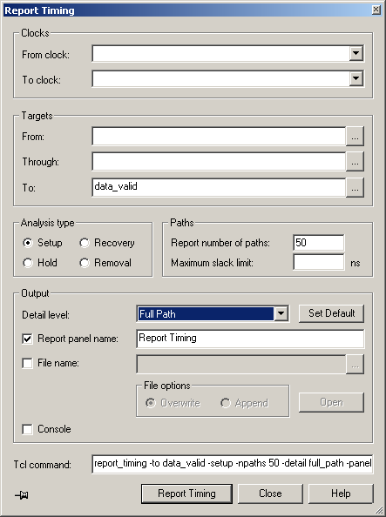

Remember that using the PLLs is one of many ways to optimize timing on a design. Whether you can use this method or not depends on other factors like the availability of PLLs, jitter tolerances, and even power consumption. For each design you try to optimize, you have to choose the best methods based on your knowledge of the design and what is easiest to implement.

Exercise Summary

- Practiced reviewing a design to determine possible causes for failing paths
- Used PLLs to optimize timing in a design

End of Exercise 3

